Reduces
Breastfeeding Stress in Mother and Baby

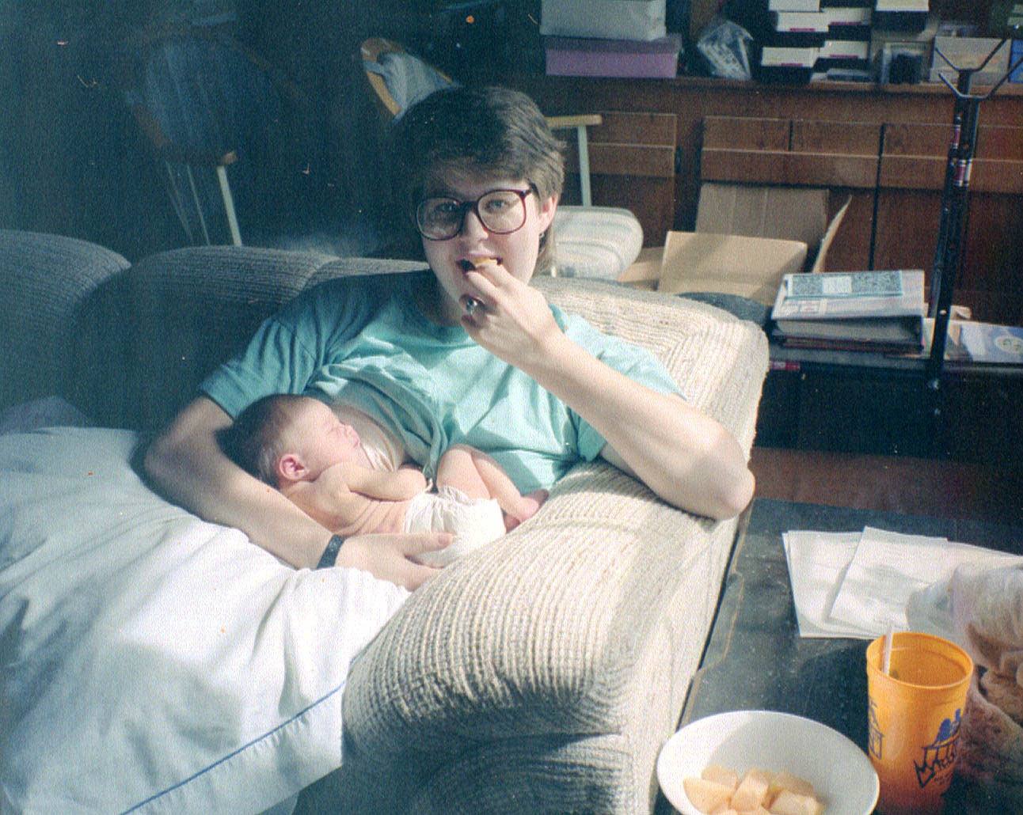  It’s ok to take time to RELAX | 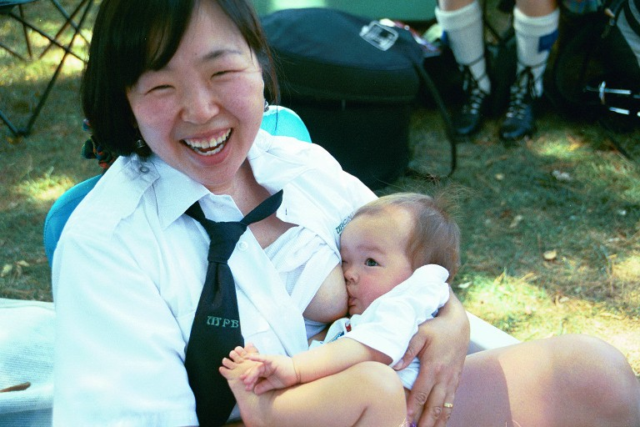  It’s also great to go OUTSIDE!
Take time to bond with your baby …AND use your free hand to read a book! | Shower your baby with the best . . .  feed from the Breast

Roses are Red, Violets are Blue,
Breastfeeding helps reduce stress in BOTH of you!

Oxytocin, a hormone released each time a mother breastfeeds, decreases blood pressure, decreases stress hormone level and calms the mother. (Acheston, L "Family violence and breast-feeding" Arch Fam Med 1995; 4:650-652)

Prolactin relaxes mom and brings out the best in her, helping her cope with the stresses of parenthood. It is associated with caretaking behavior in both females and males. (http://www.people.virginia.edu/~rjh9u/oxytocin.html)

Sucking reduces stress in infants: "Parents should recognize that having their babies cry unnecessarily harms the baby permanently," Commons said. "It changes the nervous system so they're overly sensitive to future trauma." Michael L. Commons and Patrice M. Miller, researchers at the Medical School's Department of Psychiatry. The Harvard University Gazette, April 9, 1998
For breastfeeding help, call:

ABC Program 646-4166
Dixon Family Practice 635-1600
La Clínica Great Beginnings 556-8100
Kaiser Permanente 651-5270
NothBay Warm Line 646-5024
Vacaville CMC 359-1822
For local WIC office 784-2200
For Public Health Nurse 784-8070

Breastfeeding is associated with decreased neuroendocrine response to stressors and decreased negative mood. Sibolboro Mezzacappa E. Breastfeeding and Maternal Stress Response and Health. Nutrition Reviews, Volume 62 Issue 7, pp 261–268. (Published on-line 2008. DOI: 10.1111/j.1753-4887.2004.tb00050.x)

…suppresses the response to physical and psychosocial stress…and this effect appears to last about 1 hour after feeding. Heinrichs M, Neumann I, Ehlert U. Lactation and stress: protective effects of breast-feeding in humans. Stress. 2002 Sep;5(3):195-203.

The Breastfeeding Coalition of Solano County
www.solanocounty.com/Breastfeeding

