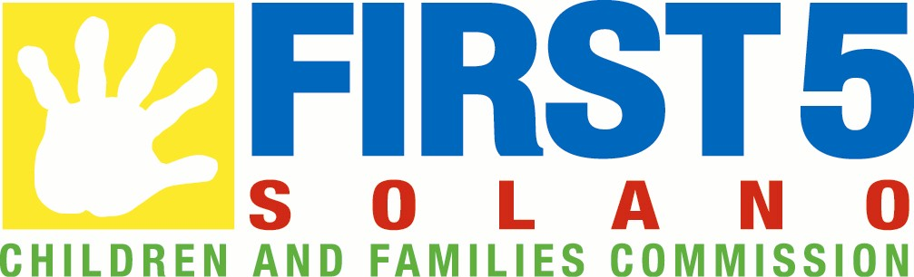
AUTHORIZATION TO USE NAME AND LIKENESS

I, ___________________________________, am a custodial parent/legal guardian of the child __________________________. I authorize the First 5 Solano Children and Families Commission to use my/my child(ren)’s name and likeness in brochures, publications, Internet web sites, advertisements, newspaper articles, etc., for promotional and educational purposes related to the goals, community programs and activities supported or sponsored by the First 5 Solano Children and Families Commission.

By completing and signing this request below, I hereby give permission and indicate consent to the release of educational information about or relative to the participation in any First 5 Solano Children and Families Commission event. Such information shall include but not be limited to the release of photographs, the reproduction of sound, motion picture, or videotape recordings, to be used in connection with various television programs or subsequent video, photographic, websites, multimedia, or audio presentations. I further grant permission to be shown on closed circuit TV systems, shared with other classes and schools, shared at community and professional meetings, aired by local cable stations, entered into educational or media contests, posted on websites and used for other purposes deemed appropriate by the First 5 Solano and its partners. I understand and agree that all media will become the exclusive property of First 5 Solano and there will be no compensation or remuneration for participation in this event.

Dated:
Parent/Guardian Signature:
Printed Name:
Address:
Telephone Number:
Child(ren)’s Name:

