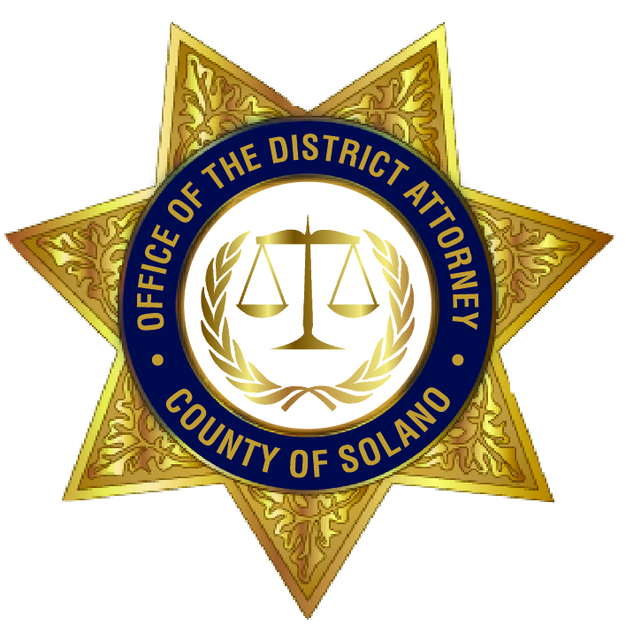

OFFICE OF THE DISTRICT ATTORNEY

COUNTY OF SOLANO

KRISHNA A. ABRAMS

DISTRICT ATTORNEY

John M. Daugherty
Chief Deputy

Sharon S. Henry
Chief Deputy

Aaron Dillon
Supervising Investigator

OFFICE OF THE DISTRICT ATTORNEY

COUNTY OF SOLANO

DAVID W. PAULSON

DISTRICT ATTORNEY
Consumer & Environmental Crimes Unit
675 Texas St., Suite 4500, Fairfield, CA 94533-6340
Phone: (707) 784-6859 / Fax: (707) 784-7986 / Email: dacepu@solanocounty.com

CONSUMER AND ENVIRONMENTAL CRIMES UNIT (CECU)
COMPLAINT INFORMATION SHEET

Enclosed you will find a Consumer Complaint Form. Please complete the form with as much detail as possible. If submitting by mail, attach copies (not originals) of all pertinent documents, contracts, work orders, receipts, canceled checks (front and back showing endorsement), or any correspondence that you may have in connection to your complaint. If submitting online, please scan any supporting documentation along with your complaint.

Before you complete the complaint form, please remember the following information. The CECU will have jurisdiction only if one of the following situations apply:

- A consumer transaction with a company that occurred in Solano County; or
- The company is located in Solano County

If none of these apply to you, please contact the district attorney’s office where you reside, where the company is located, or where the transaction occurred.

Please know that this office represents the State of California in this judicial district. The CECU is designed to protect California consumers from unlawful or unfair business practices and/or false and misleading advertising by companies or certain individuals. This office will not represent individual consumers nor will it represent individual companies.

As a point of information, a “consumer” is defined as someone who purchases or leases a service or a product which is primarily for family, household, or personal use. The definition does not include a company that complains against another company for alleged violation of law.

It is the policy of this office to have WRITTEN complaints on file before we determine if any action by this office would be appropriate.

Your complaint is very important to this office as we need to determine what consumer problems exist that may impact the State of California. If this office receives numerous complaints against a company, a basis may exist for the district attorney’s office to investigate the matter further.

Usually, this office will not file an action unless an alleged pattern of fraud exists. This office needs to receive written consumer complaints to establish such a pattern. The CECU will then monitor the business practices of a company to determine if the received complaints constitute a sufficient pattern of alleged fraud.

Although this office is prohibited from giving legal advice, we will provide information about your consumer rights. This may include referring you to the appropriate agency that would accept your complaint.

If your complaint involved a loss of $10,000.00 or less, we encourage you to talk to the Small Claims Court legal advisor Monday-Friday from 8:00 a.m. – 12:00 p.m. at (707) 422-7433 to determine if a Small Claims Court action would be appropriate.

Thank you for understanding the importance of filing consumer complaints that may ultimately lead to civil or criminal prosecution by this office.

