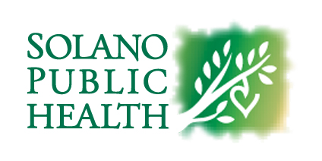

Mailed Card Acknowledgment Form

I, , wish to have my medical

Cannabis ID card mailed to me. I acknowledge that, although the card will be mailed to me within five days after it is received by Solano County, I may or may not receive it within that five-day period. Solano County is not responsible for a lost, stolen, or undelivered mailed medical cannabis ID card(s) through the United States Postal Service.

____________
Signature Date

275 Beck Avenue, Fairfield CA 94533 P (707) 784-3111 F (707) 784-1467
