[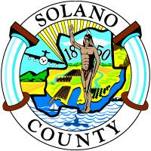](http://hssweb/Solano%20County%20Seal/JPG_200X200.jpg)

**Solano County Alcohol and Drug Advisory Board**

Current Board Members and Vacancies

|  |  |
| --- | --- |
|  |  |
| **Christie Lynn DeClue** | **Chairperson** |
| *Date Appointed:* | 5/7/2013 |
| *Term of Office:* | 5/7/2013 – 5/7/2016 |
|  |  |
| **Tracey Lee** | **Vice-Chairperson** |
| *Date Appointed:* | 11/25/2014 |
| *Term of Office:* | 11/25/2014 – 11/25/2017 |
|  |  |
| **Gene Korte** | **Board Member** |
| *Date Appointed:* | 4/8/2014 |
| *Term of Office:* | 4/8/2014 – 4/8/2017 |
|  |  |
| **Debra A. Sanderson (Debi)** | **Board Member** |
| *Date Appointed:* | 6/10/2014 |
| *Term of Office:* | 6/10/2014 – 6/3/2017 |
|  |  |
| **Kent Shaw** | **Board Member** |
| *Date Appointed:* | 8/27/2013 |
| *Term of Office:* | 8/27/2013 – 8/27/2016 |
|  |  |
| **Currently, we have four vacancies. Please contact Kristina V. Feil, ADAB Board Assistant at kvfeil@solanocounty.com for an application.** | |