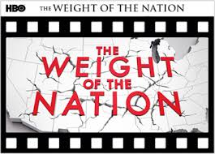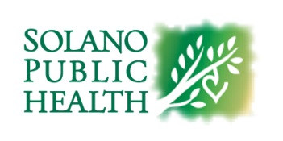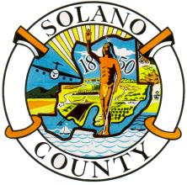

**Solano Public Health will host a viewing of Nashville Takes Action: A City Battles Obesity.**

**The documentary is a part of the HBO series, The Weight of the Nation.**

**Learn how Nashville’s city leaders, with help from the federal government, have taken a proactive role in trying to make the healthy choice the easy choice for its citizens.**

**When: April 2nd, 2014, from 3:00 pm to 5:00 pm**

**Where: 675 Texas Street, Fairfield, Board of Supervisors Chambers**

**There will be a panel discussion after the viewing.**

**Community members interested in obesity prevention efforts at the local level are welcome to attend.**

**Questions can be directed to Amber Siddle-Manas at (707) 784-2163**