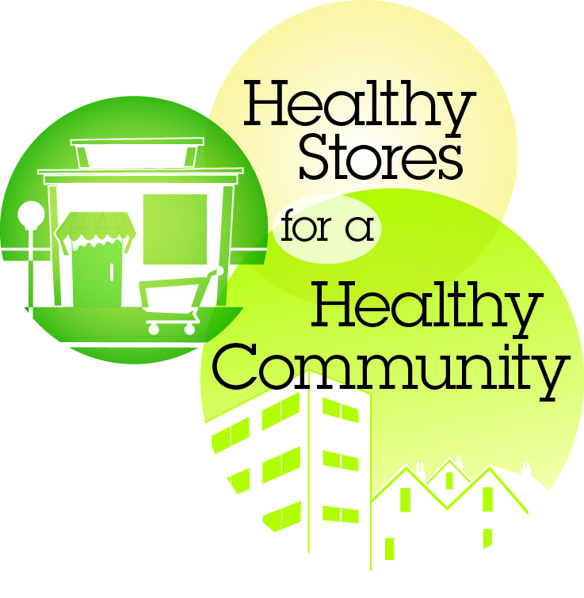**FOR IMMEDIATE RELEASE**

March 5, 2014

**CONTACT:** Jayleen Richards or Meileen Acosta, 707-784-8616 or 707-784-8600 x1

**Solano County Stores Rank Higher Than State in Sale of Unhealthy Products and Promotion to Kids**

***The First and Largest Survey of its Kind in California Analyzing Tobacco, Alcohol and Food in Stores***

SOLANO COUNTY - New data reveal that nine out of ten stores in Solano County that sell tobacco products sold products that appeal to kids—with flavors like chocolate and grape—a much higher rate than the state. In contrast, only a quarter of stores sell low- or non-fat milk—one of the lowest rates in the State.These findings are part of new data released today on the availability and marketing of tobacco, alcohol and unhealthy and healthy food products in stores that sell tobacco—the first time all three categories of products have been analyzed together.

Health advocates across the state released the survey results today, with 13 press events taking place simultaneously throughout California. The large survey collected information from more than 7,300 diverse retail stores—including convenience, supermarket, liquor, tobacco, small market, discount, drug and big-box stores—in all 58 counties, with the goal of shedding light on what products are available and promoted in our communities. Nearly 700 public health representatives, community volunteers and youth participated in the survey, which was conducted from July through October 2013.

“We have made progress over the years to reduce tobacco use, but as these survey results show, the tobacco industry and other companies offering unhealthy products are continuing to find new ways and new products to entice Solano youth, like flavored cigars which are the same price as a pack of gum. These are being marketed throughout Solano County, many times in stores just a few blocks from schools,” said Dr. Michael Stacey, Solano County’s Chief Medical Officer and Deputy Health Officer. “We are committed to working with retailers, parents and partners throughout Solano County to protect our kids and make our communities healthier.”

Survey results show that nearly four out of five (79 percent) stores in Solano have advertising for unhealthy products on the outside of the store and more than half of stores that sell alcohol have alcohol advertising near candy or toys or at a child’s eye level.

“We all need to stop and notice how many unhealthy messages are surrounding kids every day,” said Grace Baxter, an Armijo High School student who participated in the store survey. Solano County Tobacco Prevention and Education Program recruited 83 volunteers to help staff conduct the survey county-wide, 49 of whom were youth. Solano County had the highest number of youth who participated in any California county. “Research shows that kids are highly influenced by marketing of products like tobacco and alcohol, even more so than peer pressure. We felt it was important to include youth in this campaign because it is their health that is at stake. Their choices now could lead to either a healthy lifestyle or to obesity, chronic disease and even premature death,” said Dr. Stacey.

The findings also show that electronic cigarettes (e-cigarettes) are widely available in Solano County, alarming Health officials and community partners. Three out of five (60 percent) stores in Solano sell e-cigarettes. Statewide, the number of stores selling e-cigarettes quadrupled in the last two years, from 11.5 percent in 2011 to 45.7 percent in 2013. “E-cigarettes are an addictive product that is being marketed in retail stores and available in these outlets,” said Dr. Stacey. “Their widespread availability could undermine the great work we’ve done on reducing tobacco use in California.”

The survey includes state, regional and county level data with new insights on the density of stores selling tobacco and their proximity to schools; types of tobacco and alcohol products being sold; advertising and placement of such products in stores; and the availability and promotion of unhealthy and healthy food options including low- or non-fat milk and fresh fruits and vegetables.

Additional survey findings from Solano County show that kids and low-income neighborhoods are particularly exposed to unhealthy products, advertising and lower-priced unhealthy products:

* 91 percent of stores in Solano sell flavored tobacco products, such as chewing tobacco, dissolvable tobacco and little cigars, compared to 79 percent statewide. These products come in flavors like grape, cherry and mint which appeal more to kids and may get them started on using tobacco. These products are sold more frequently in low-income areas (97 percent of stores) compared to non-low-income areas (87 percent of stores).
* 94 percent of stores in Solano sell little cigars or cigarillos, compared to 84 percent statewide, and the availability of these products is higher in stores near schools (96 percent) than in stores not near schools (85 percent). Little cigars/cigarillos are cheap—most stores in Solano County sell single cigarillos for under a dollar, cheaper than a candy bar.
* The price of a pack of cigarettes in low-income areas in Solano is about 10 percent less than in non-low-income areas. The average price of $4.07 is well below the state average of $4.30. Young people and those with lower incomes are more price-sensitive.
* Nearly two out of three (63 percent) Solano stores displayed sugary drinks at the checkout, also higher than the state average; but even more stores in low-income areas, 72 percent, display these compared with 58 percent of stores not in low-income areas.
* More than two out of three (67 percent) stores in Solano had exterior alcohol advertising, compared to 54 percent statewide. Interior alcohol advertising near candy was found in 57 percent of stores near schools, compared to 49 percent of stores not near schools.
* Only a third of stores in Solano are selling good quality, fresh fruits and vegetables.

Today’s data release also marks the launch of *Healthy Stores for a Healthy Community*, a statewide campaign—formed by tobacco prevention, nutrition and alcohol prevention partners working in collaboration—to improve the health of Californians by informing them about the impacts of unhealthy product marketing in the retail environment.

In Solano County, the relationships are strong and growing and a local meeting of partners, including youth, is planned for early April when community-specific data will be shared and discussions will begin on how to build on strengths and address needs that were uncovered by the survey. For more information on this event, contact Felicia Flores-Workman at (707) 784-8901.

For state, regional and county data and more information on *Healthy Stores for a Healthy Community*, visit [www.HealthyStoresHealthyCommunity.com](http://www.HealthyStoresHealthyCommunity.com).

# # #